How to make my Tenda smart plug work with Amazon Alexa?
Tenda SP3 is used for example here.
Step 1 Open the Beli App, and tap “Login”.
Note: If you do not have a Tenda Beli account, tap “Create Account” and follow the on-screen instructions to create one. Then log in with the account.
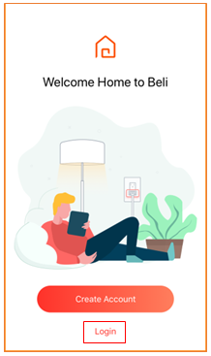

Step 2 Enter your email address and password, and tap “Login”.
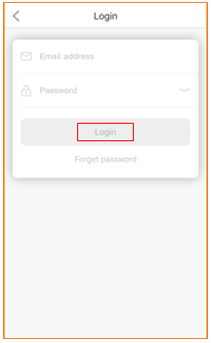

Step 3 Use the Beli App to control your Tenda smart plug.
Note: If you have already controlled the smart plug, skip this step and go to Step 4.
Tap “Add a Device”, and follow the on-screen instructions to control and name your smart plug. For example, name the smart plug “Plug test”.
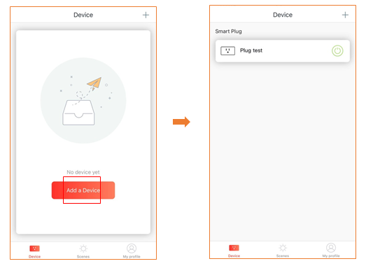

Step 4 Connect your Tenda smart plug to Amazon Alexa.
1. Open the Amazon Alexa App, and tap the "Home" button icon in the bottom left corner. Then tap the navigation menu icon in the top left corner.
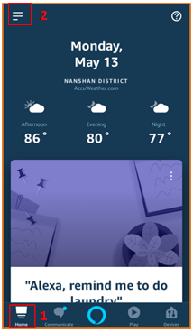

1
2. Choose “Skills & Games”.
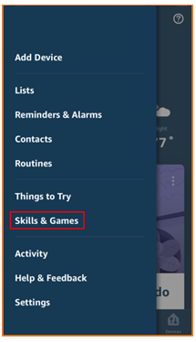

3. Tap the search icon in top right corner, enter “Tenda” and tap “Search”. Then choose “Tenda Beli”.
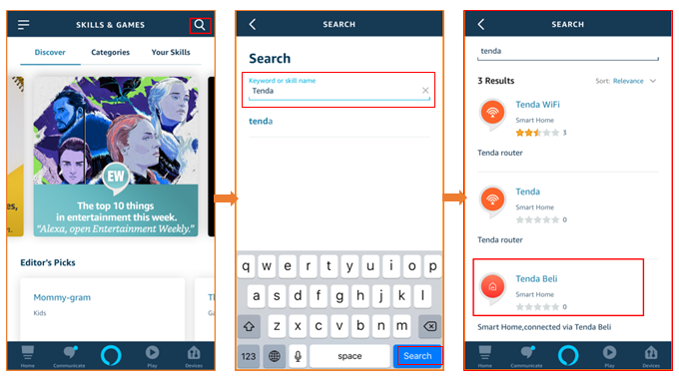
4. Tap “ENABLE TO USE” to enable the skill.
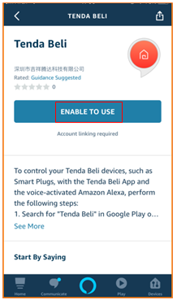
5. Enter the email address and password of your Tenda Beli account, and tap “Login”.
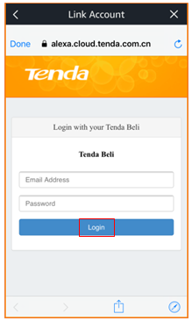

6. Tap “Done”. The Discover Devices page will automatically pop up.
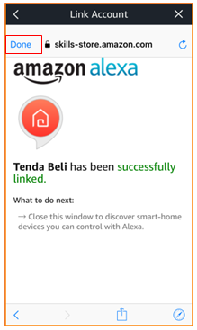

7. Choose “DISCOVER DEVIC”, and wait for a moment.
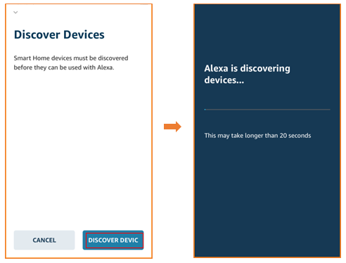

You can choose whether or not to group your smart plug. If not, tap “SKIP”, and then “DONE”.
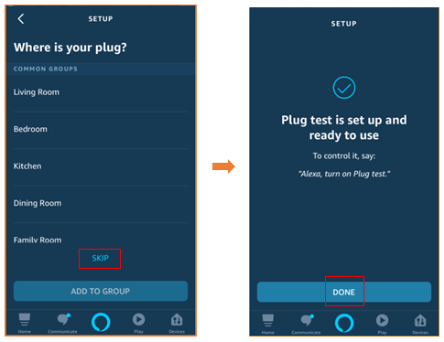
Done.
Now you can control your Tenda smart plug with Alexa.

